Chapter 3, Problem 20.

For the circuit in Fig. 3.69, find v₁, v₂, and v₃ using nodal analysis.

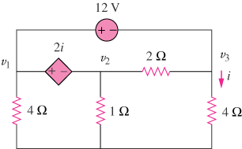

Figure 3.69
For Prob. 3.20.

